1-

select SUBSTR(STDNAME,1,5)

FROM Student

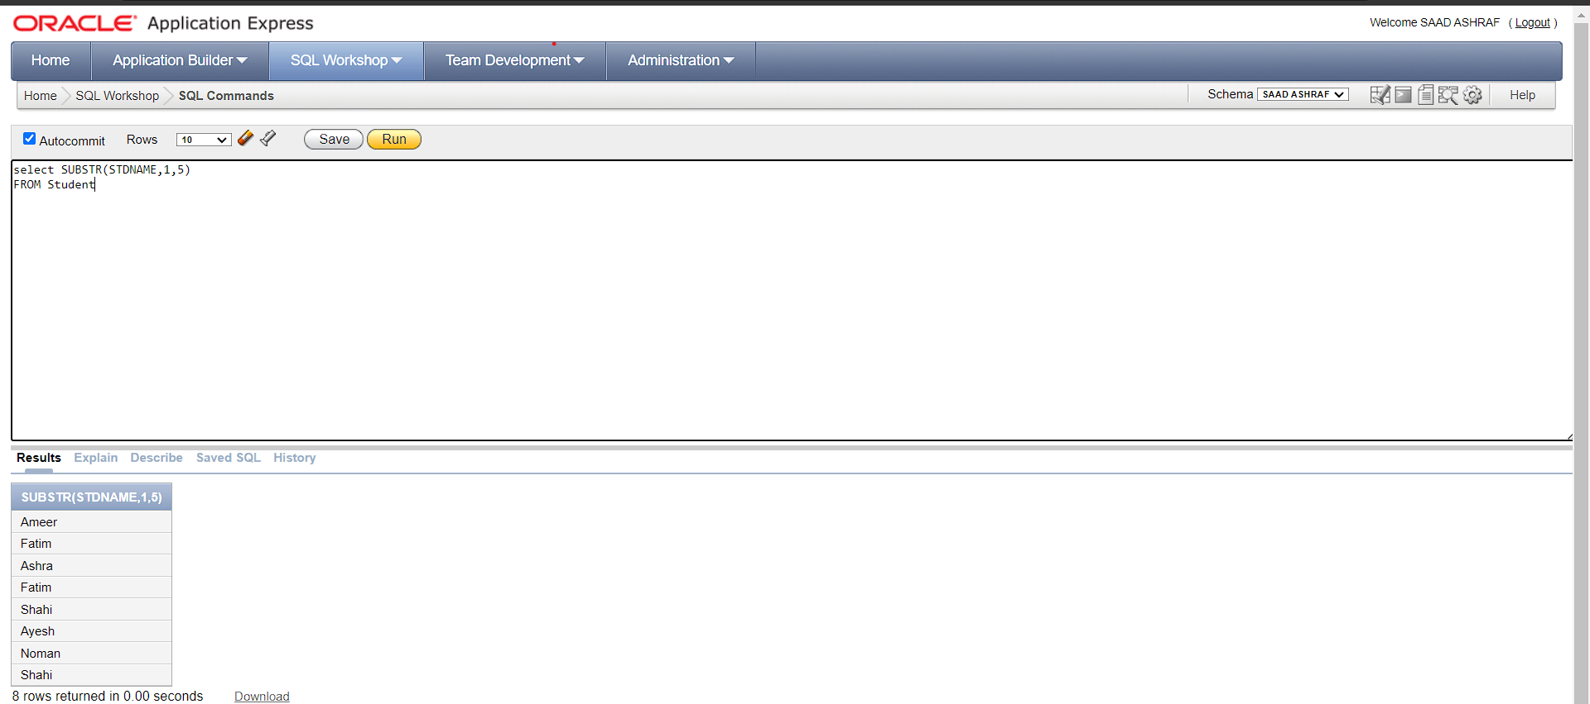

2-

select Length(STDNAME)

FROM Student

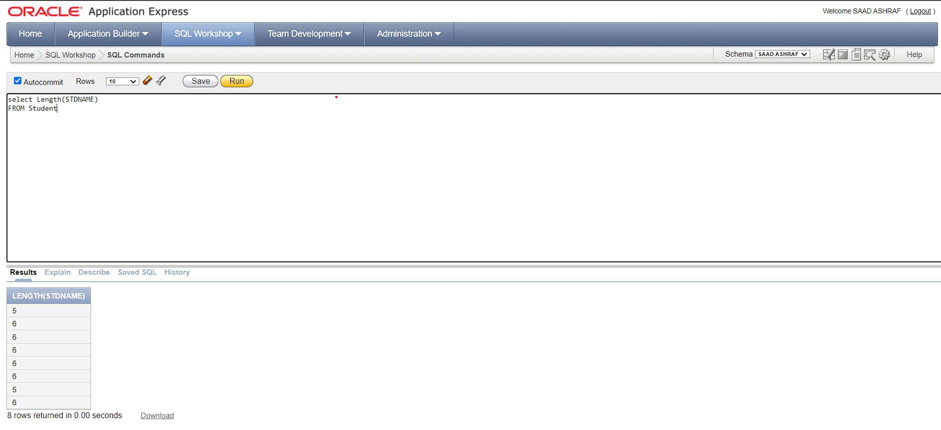

3-

select STDNAME, Replace(STDNAME, 'Ameer','Saad') as replaced

FROM Student

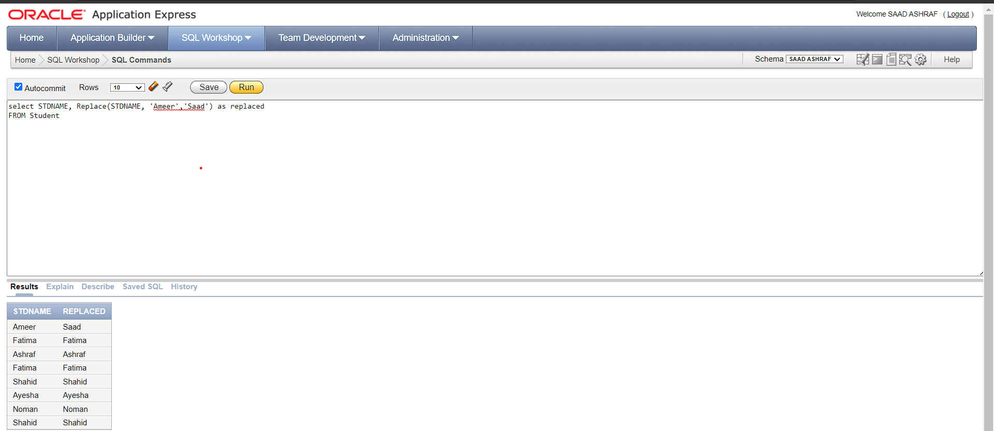

4-

select LOWER(STDNAME) FROM Student;

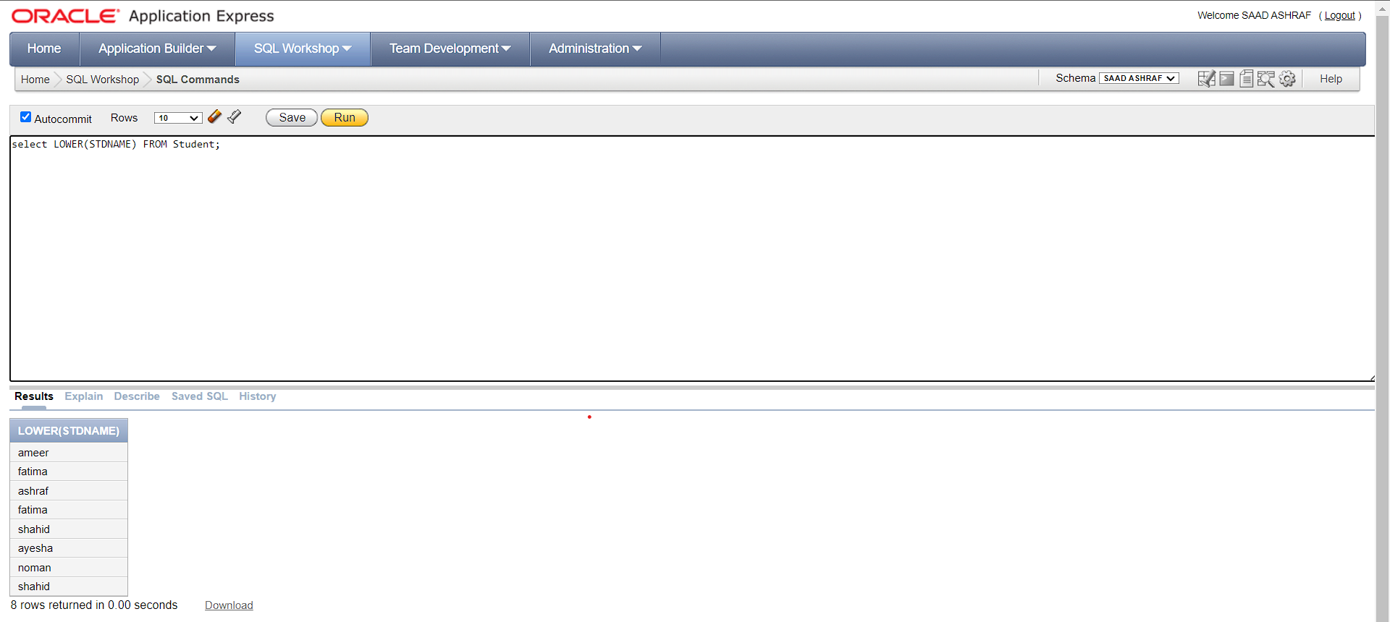

5-

select UPPER(STDNAME) FROM Student;

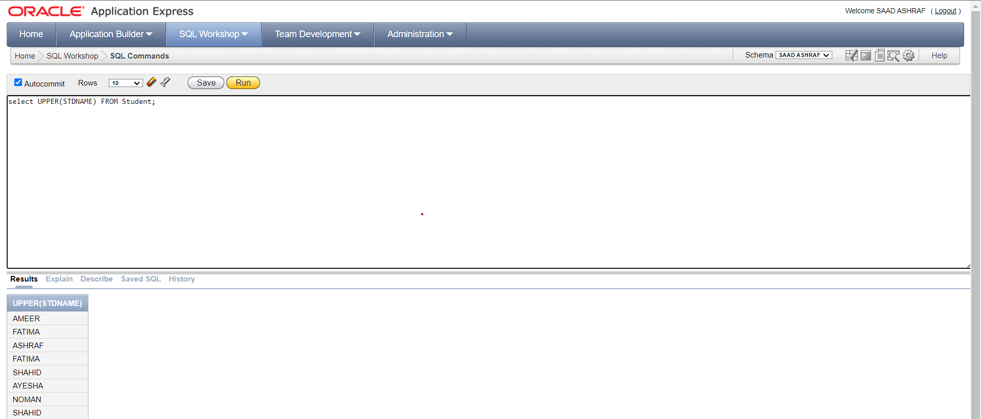

6-

SELECT CONCAT(STDNAME, STUDENT_ID) FROM Student;

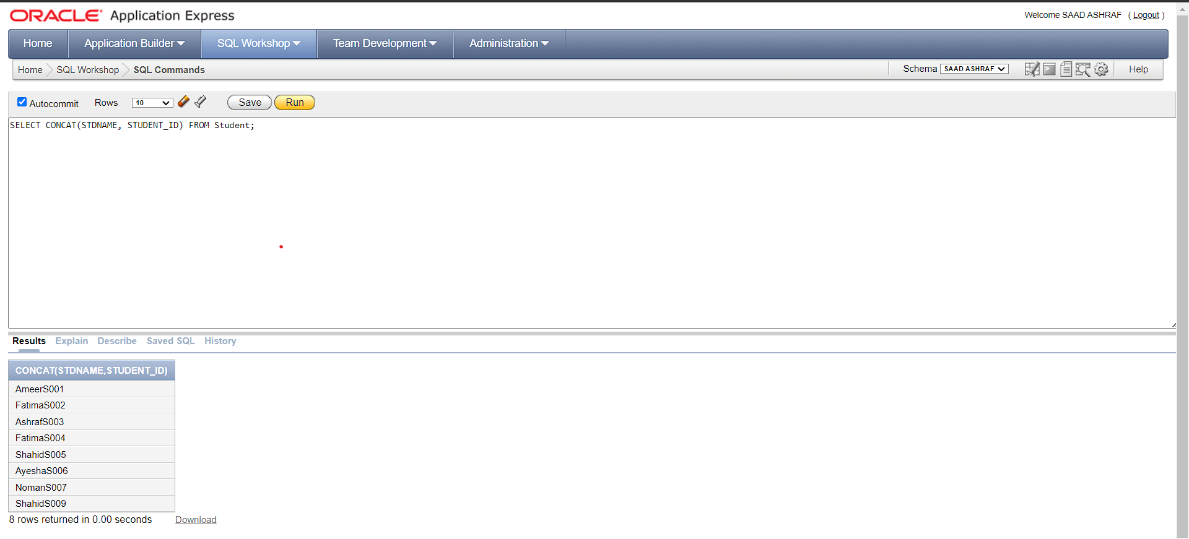

7-

SELECT SUBSTR(STDNAME, 1, 3) AS First_Three_Chars FROM Student;

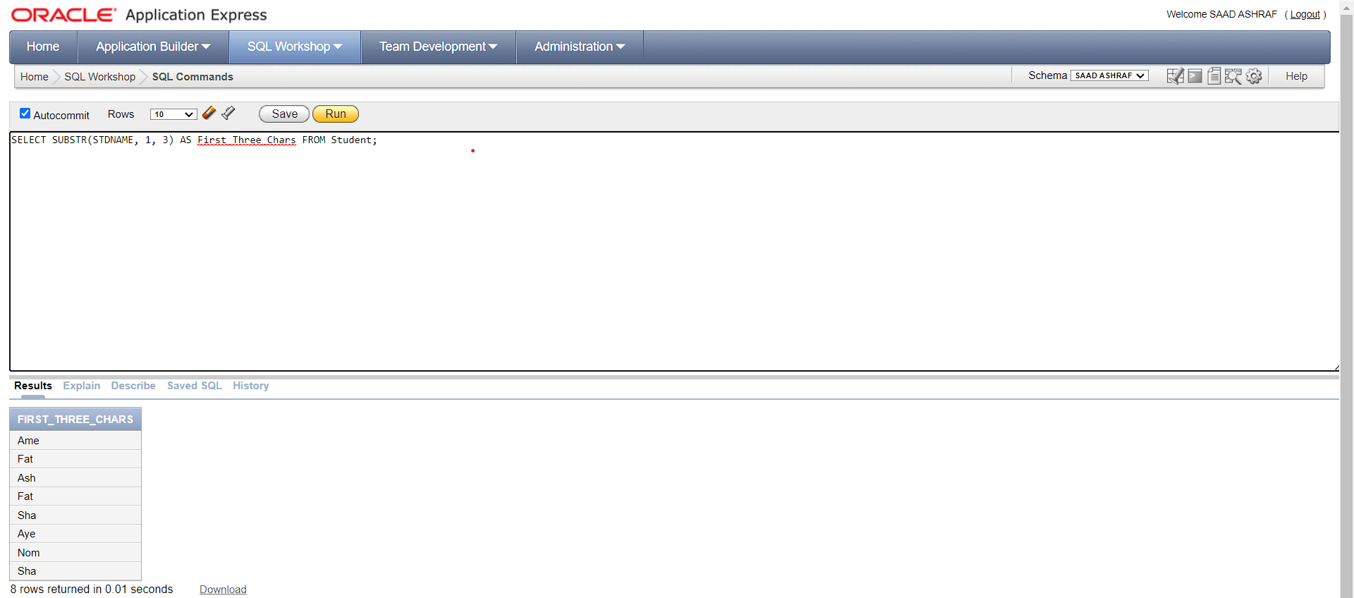

8-

SELECT TRIM(BOTH ' ' FROM STDNAME) AS Trimmed_Name FROM Student;

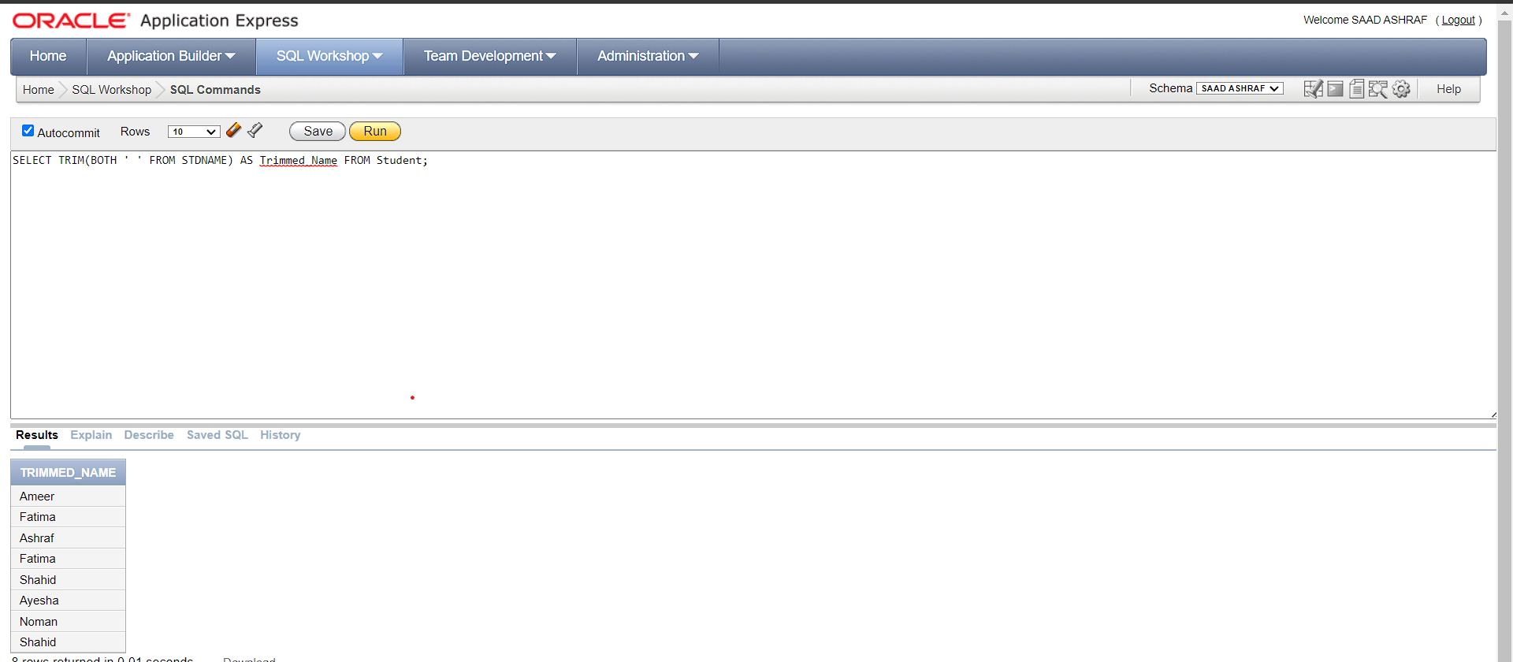

9-

SELECT INSTR(STDNAME, 'A') AS Position_Of_A

FROM Student;

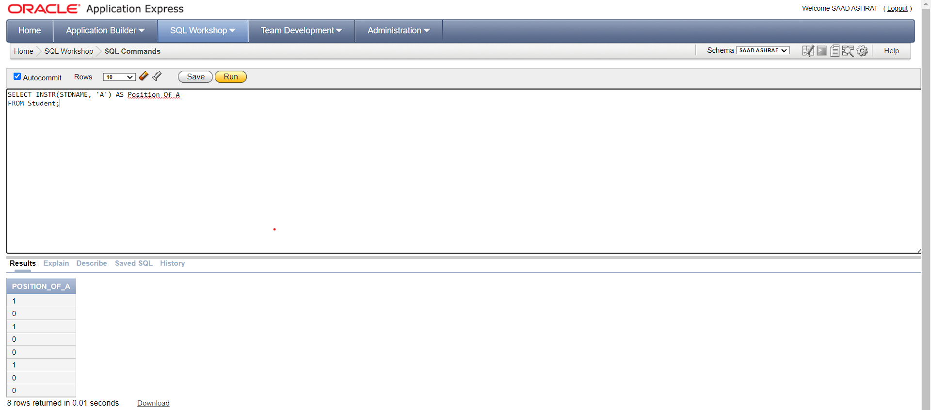

10-

SELECT LPAD(STDNAME, 10, '.') AS Padded_Name

FROM STUDENT;

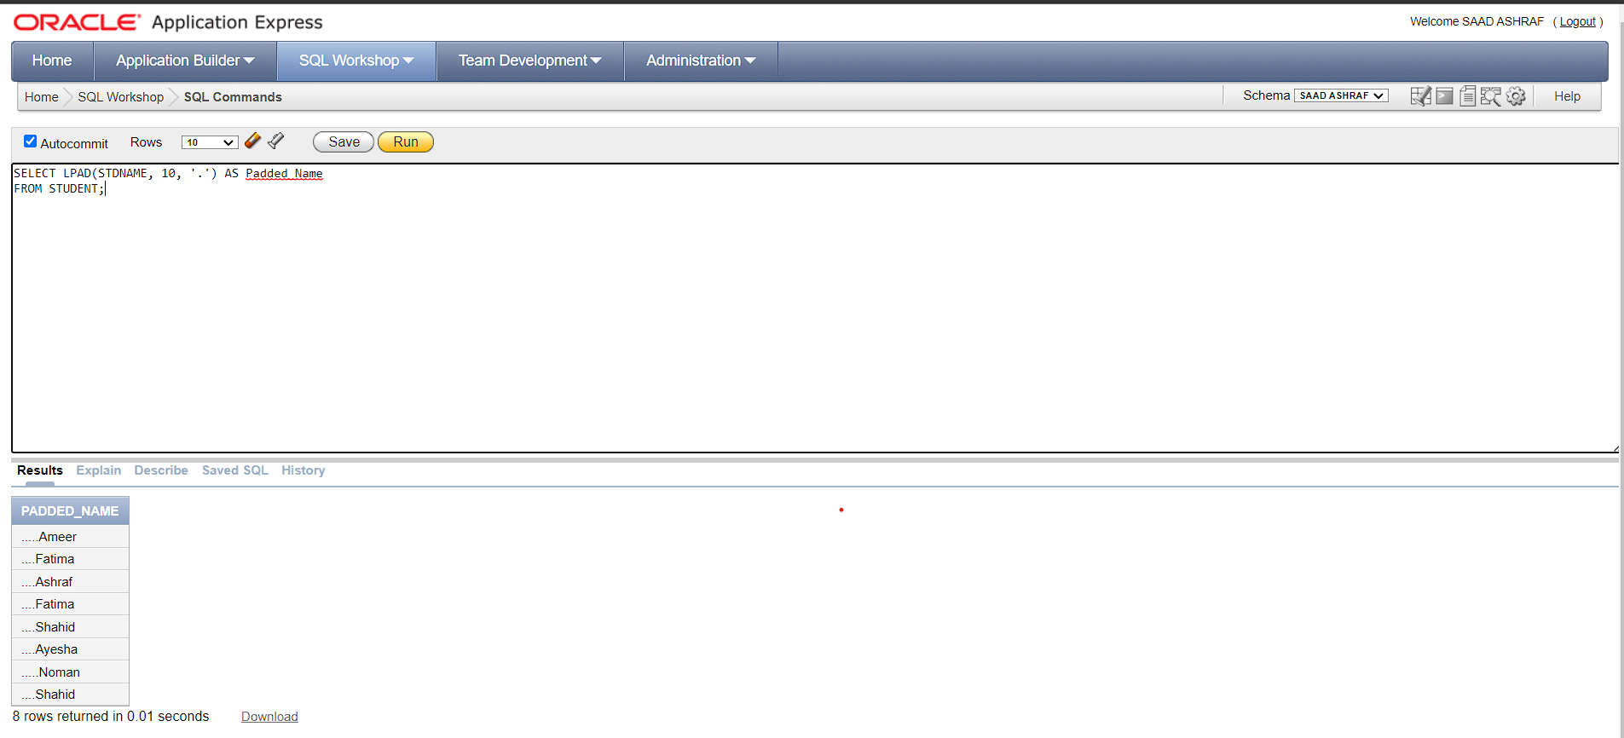

11-

SELECT RPAD(STDNAME, 10, '.') AS Padded_Name

FROM STUDENT;

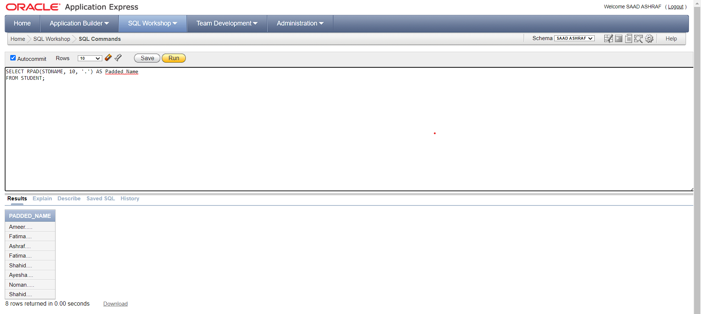

12-

SELECT INITCAP(STDNAME) AS Capitalized_Name

FROM Student;

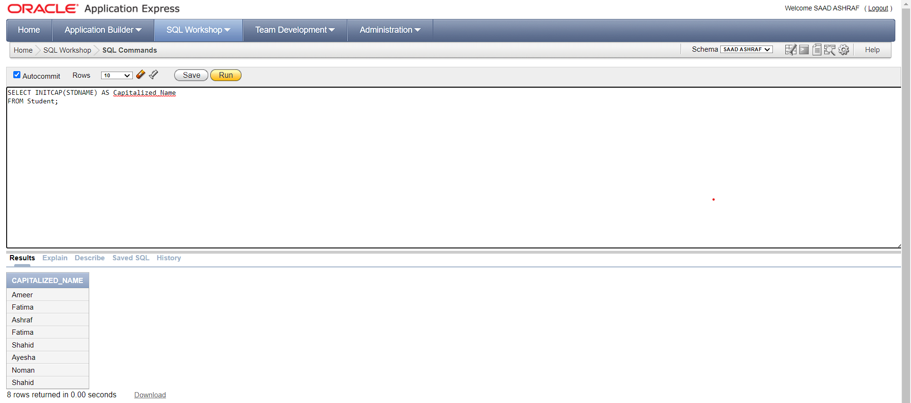

13-

SELECT TRANSLATE(STDNAME, 'ASN', '123') AS Translated_Name

FROM Student;

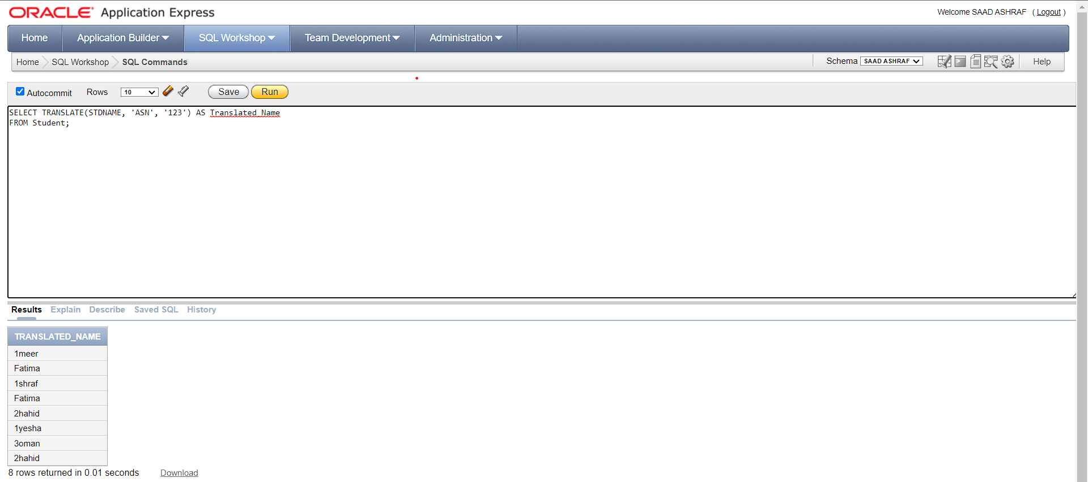

14-

SELECT REGEXP_REPLACE(STDNAME, 'I(.*)H', 'R\1N') AS Replaced_Name

FROM Student;

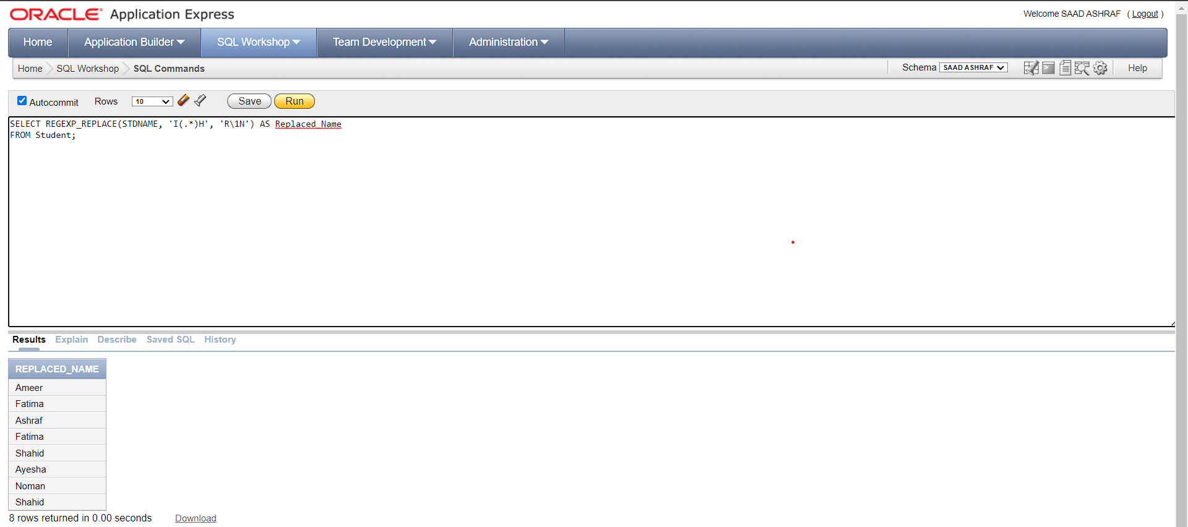

15-

SELECT COUNT(STDNAME)

FROM Student;

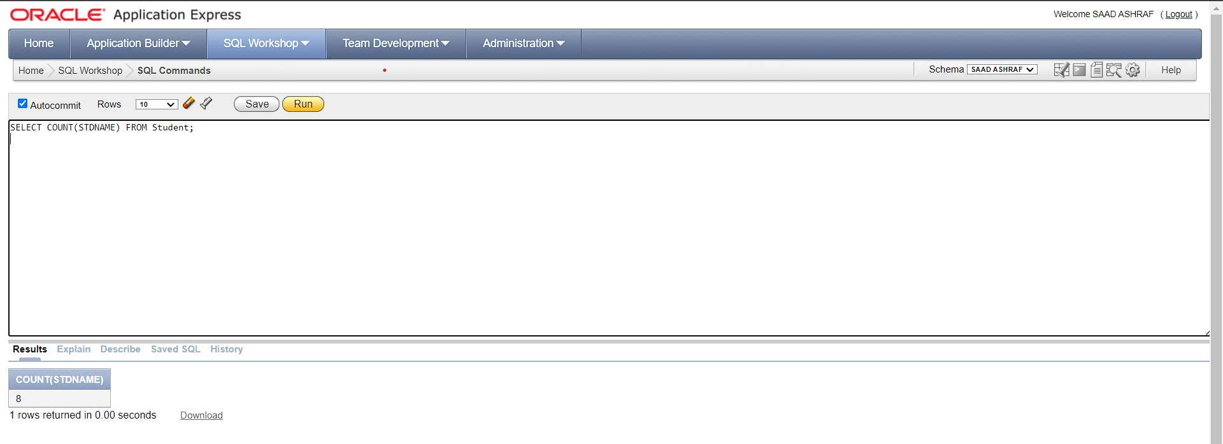

16-

SELECT MAX(Student_ID)

FROM Student;

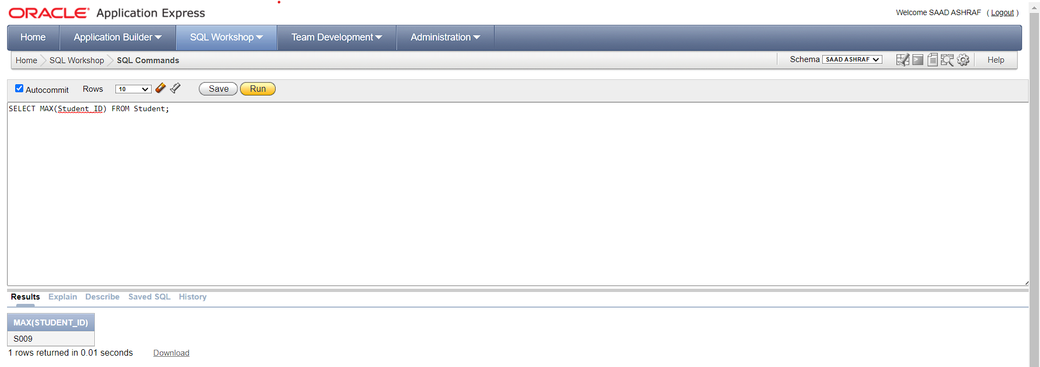

17-

SELECT MIN(Student_ID)

FROM Student;

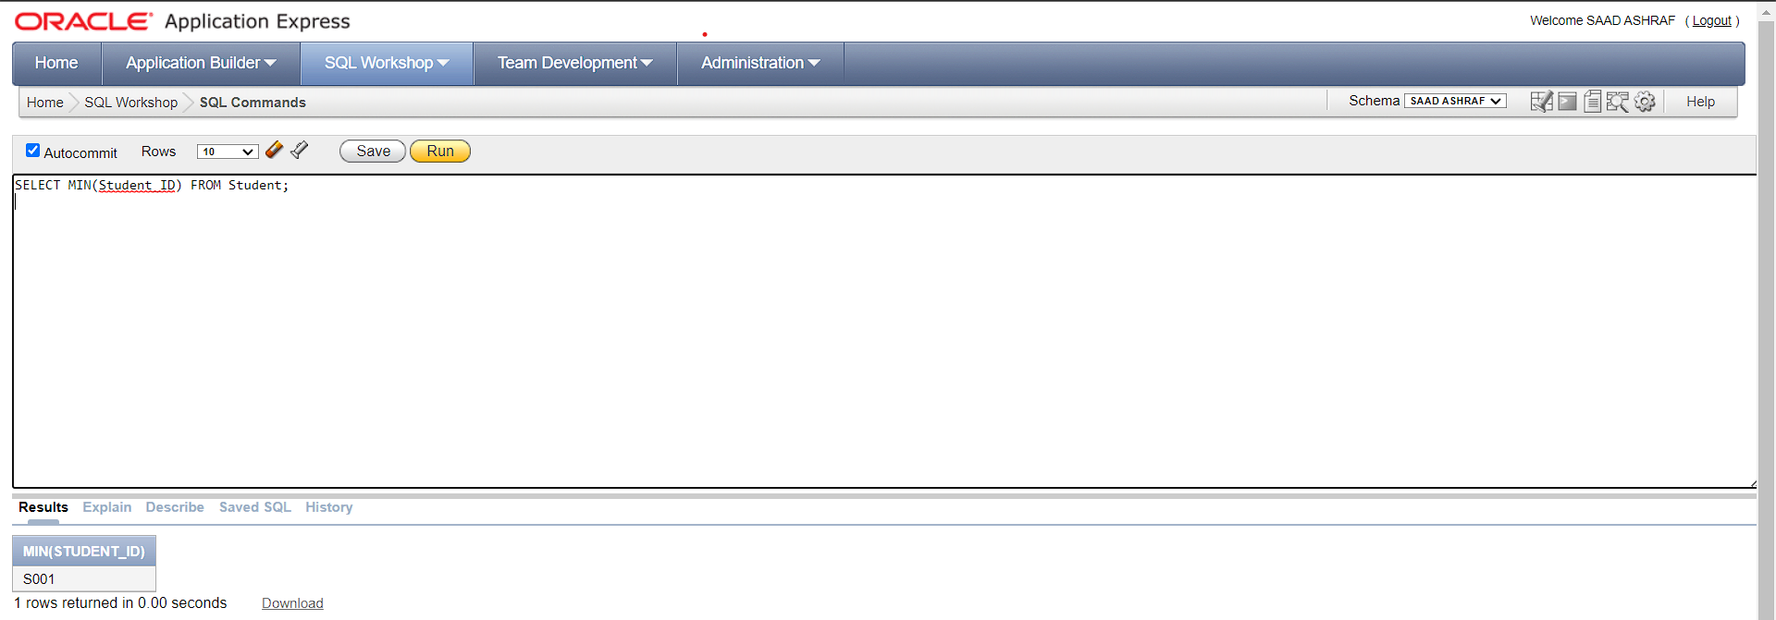

18-

SELECT REVERSE(STDNAME)

FROM Student;

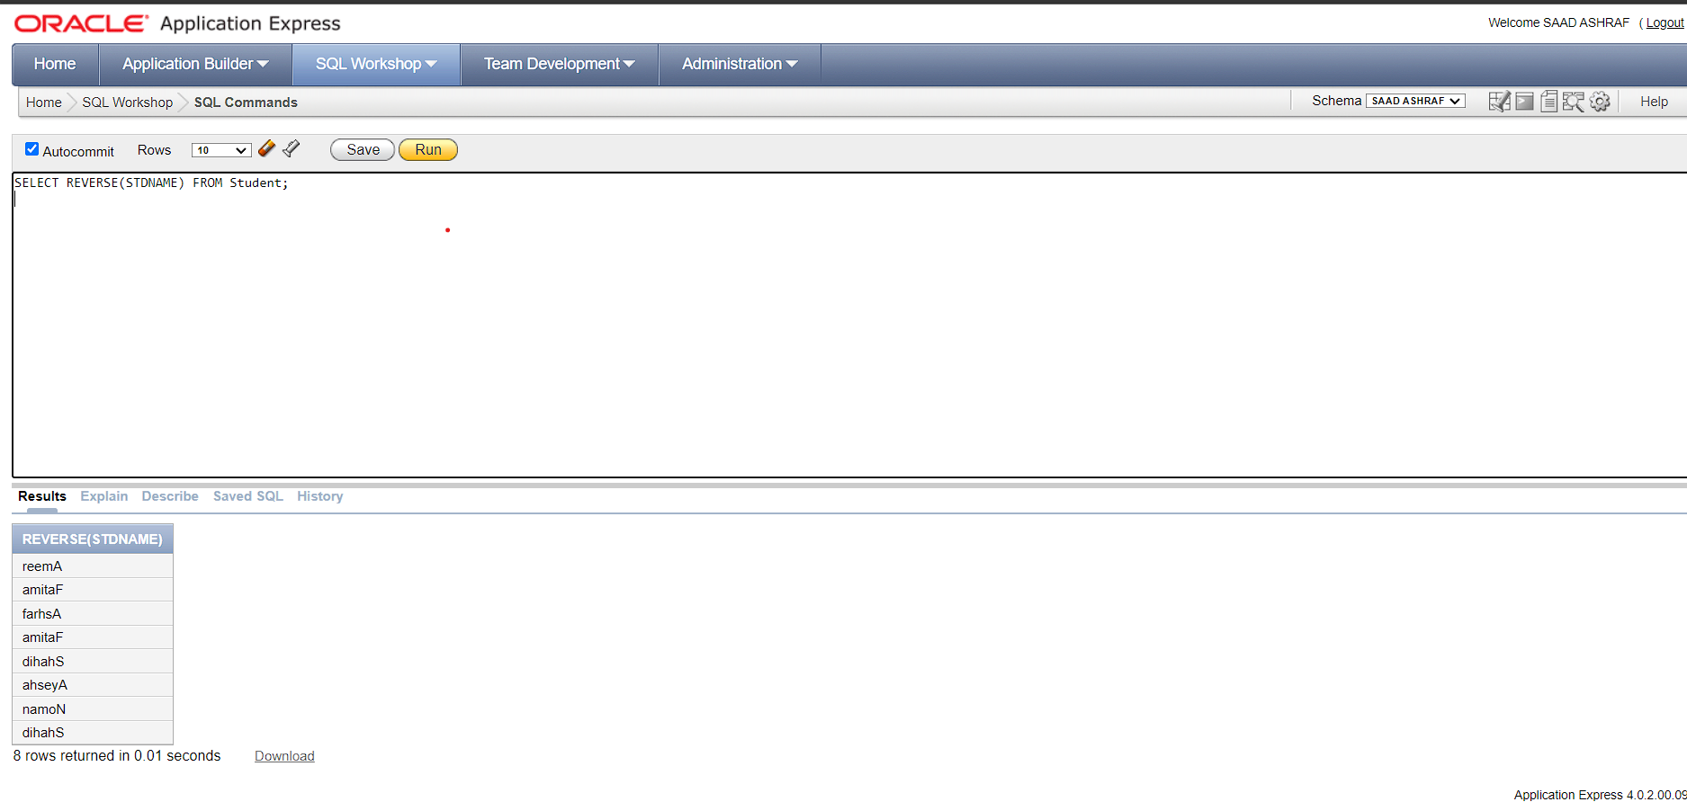

19-

SELECT ASCII(STDNAME)

FROM Student;

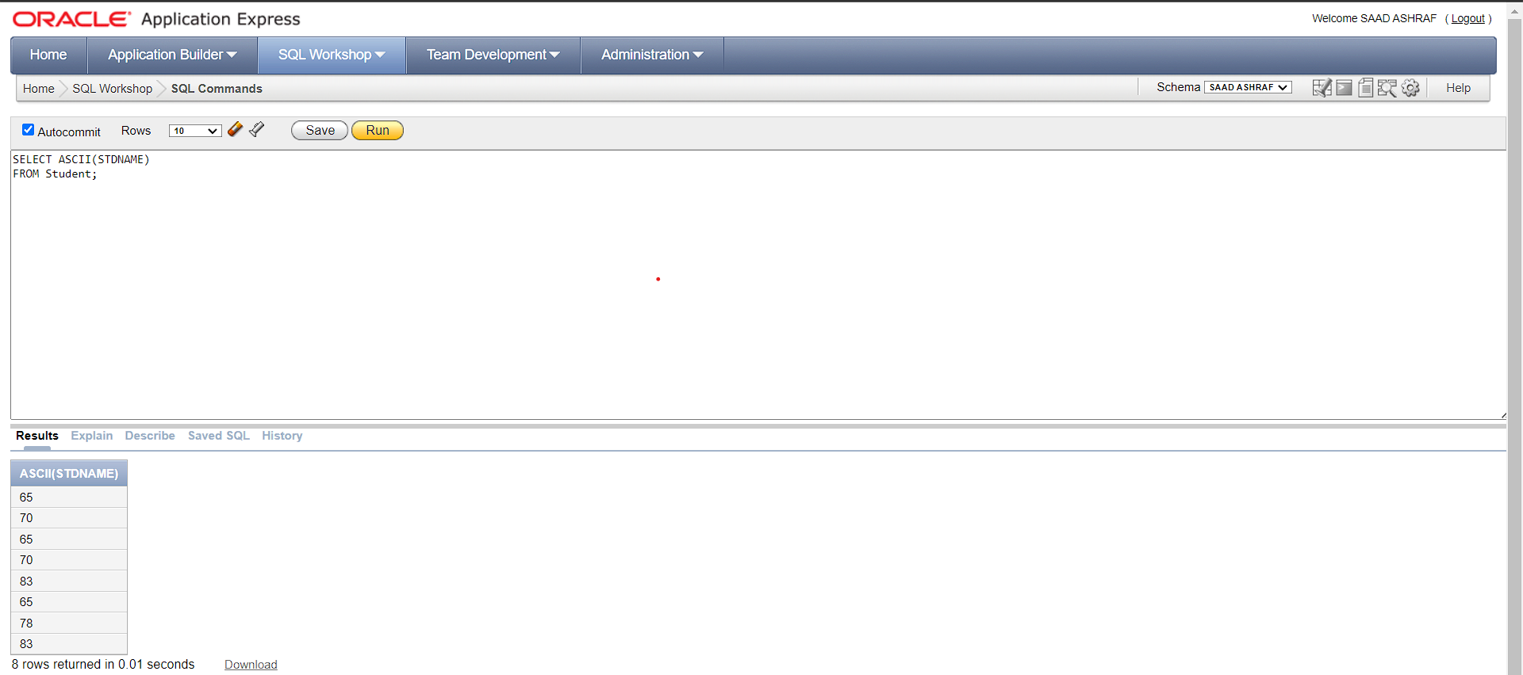

20-

SELECT RTRIM(STDNAME) FROM Student;

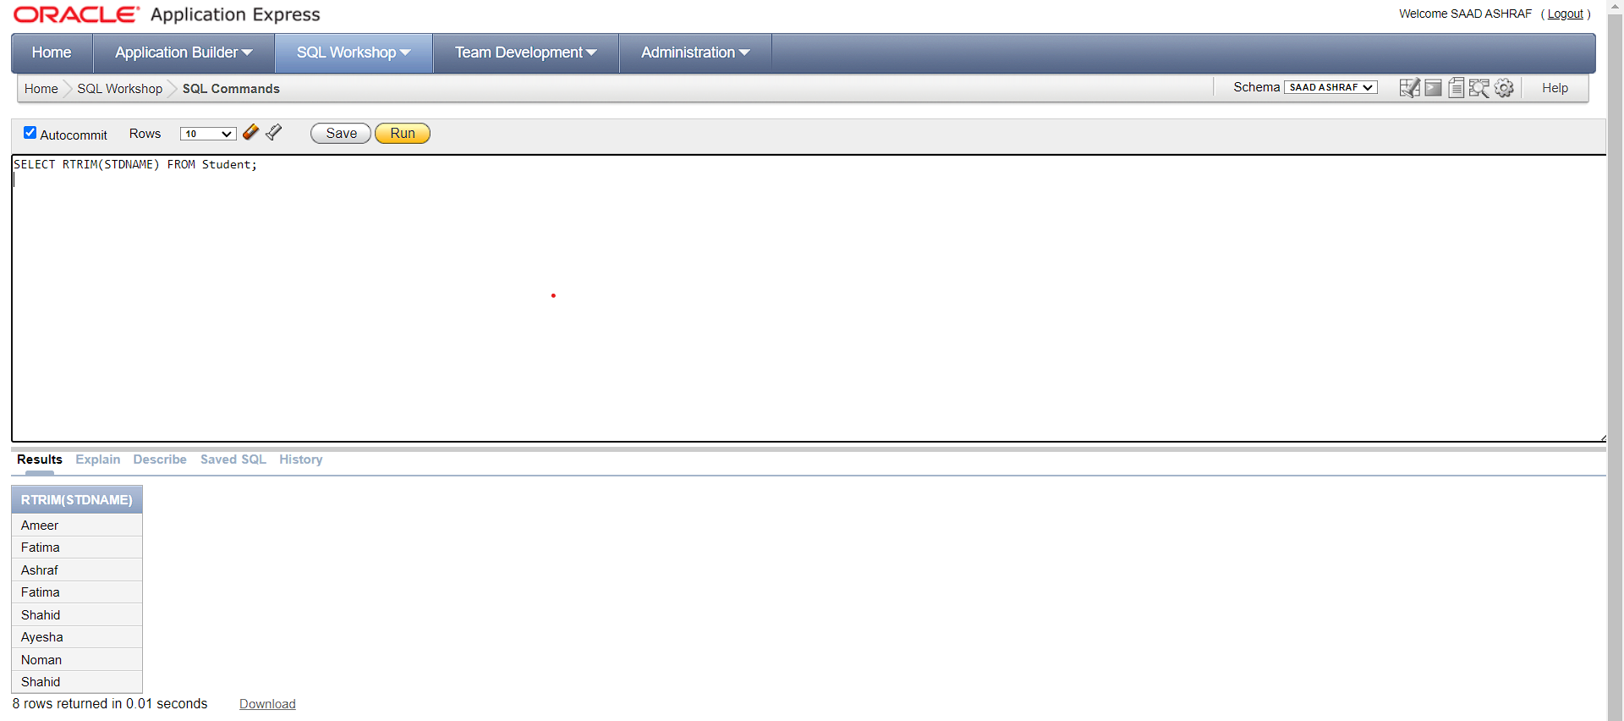

21-

SELECT LTRIM(STDNAME) FROM Student;

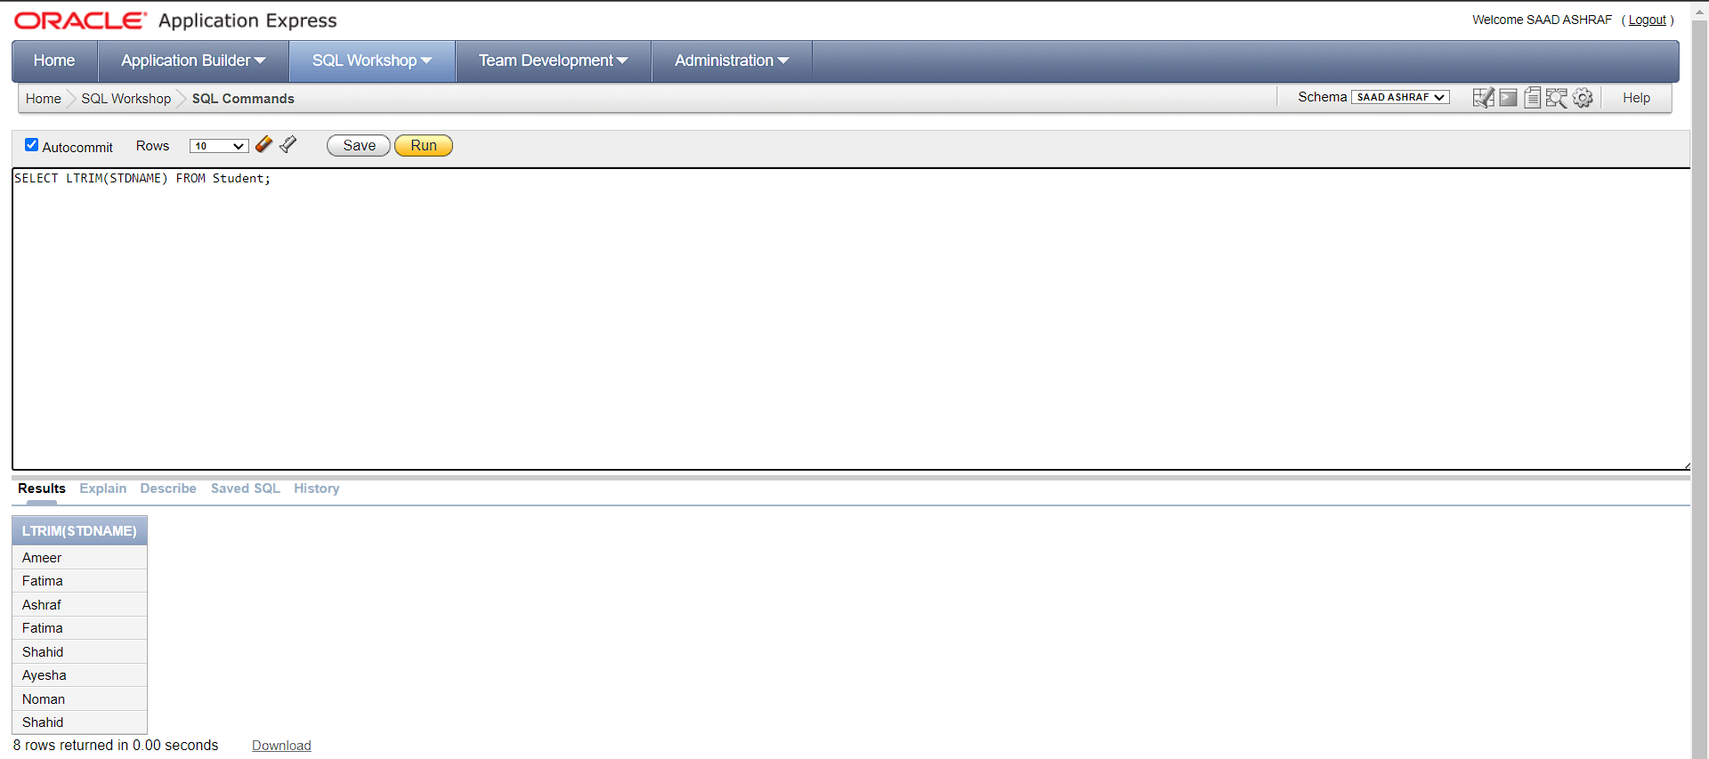

22-

SELECT ABS(20)

FROM Student;

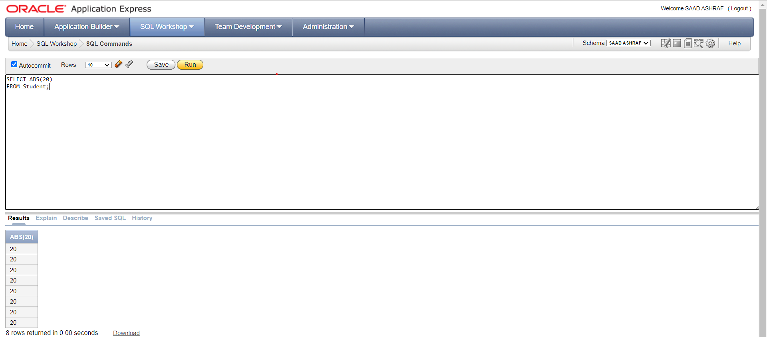

23-

SELECT CEIL(4.2324)

FROM Student;

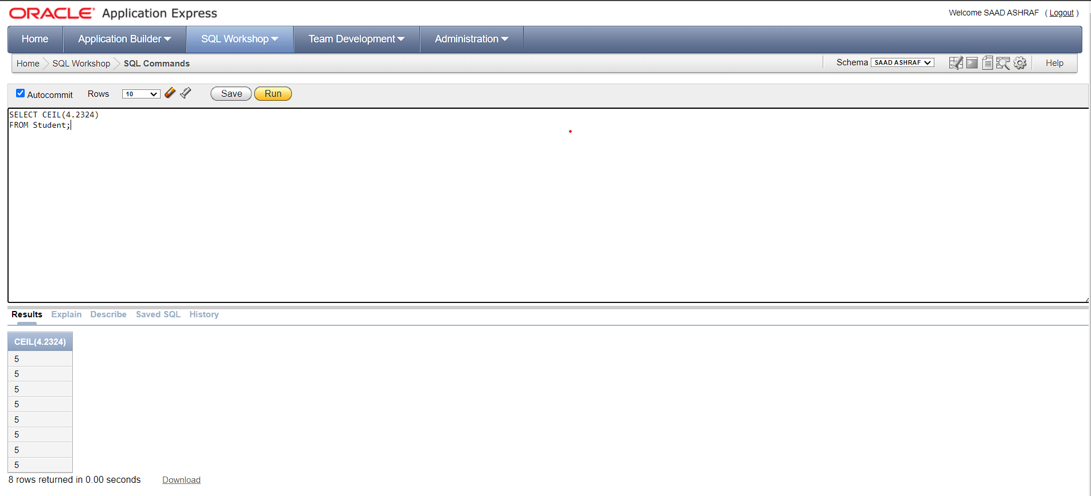

24-

SELECT FLOOR(3.12172)

FROM Student;

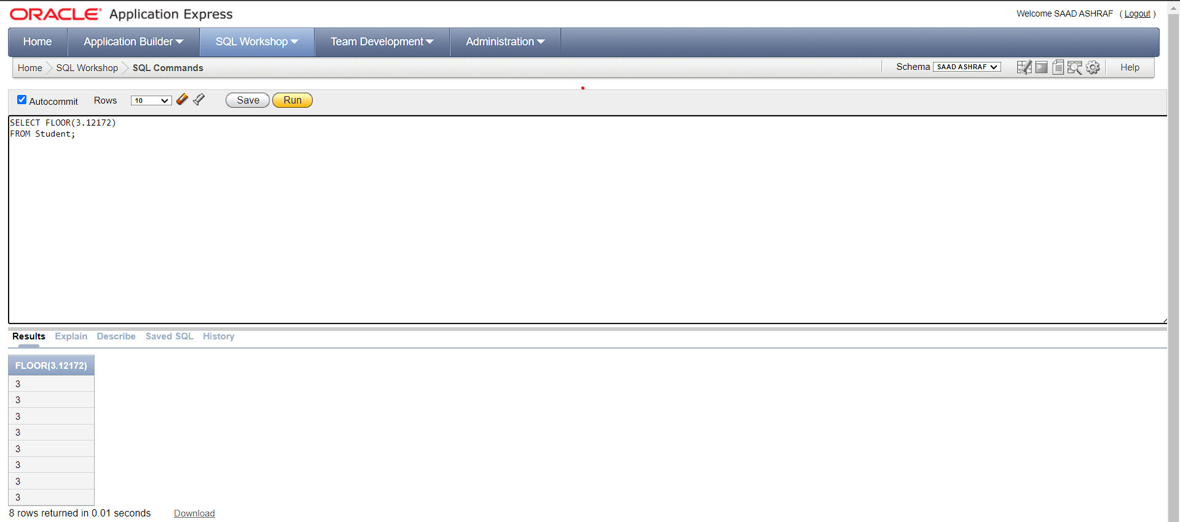

25-

SELECT MOD(10, 2)

FROM Student;

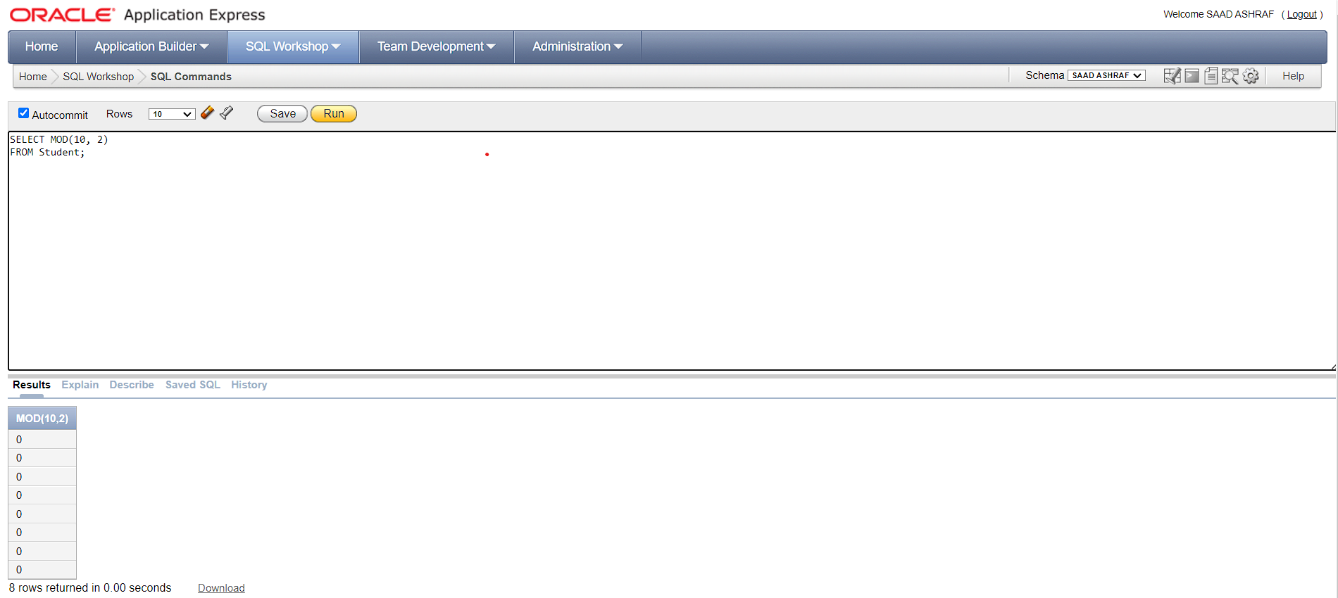

26-

SELECT ROUND(3.123, 2)

FROM Student;

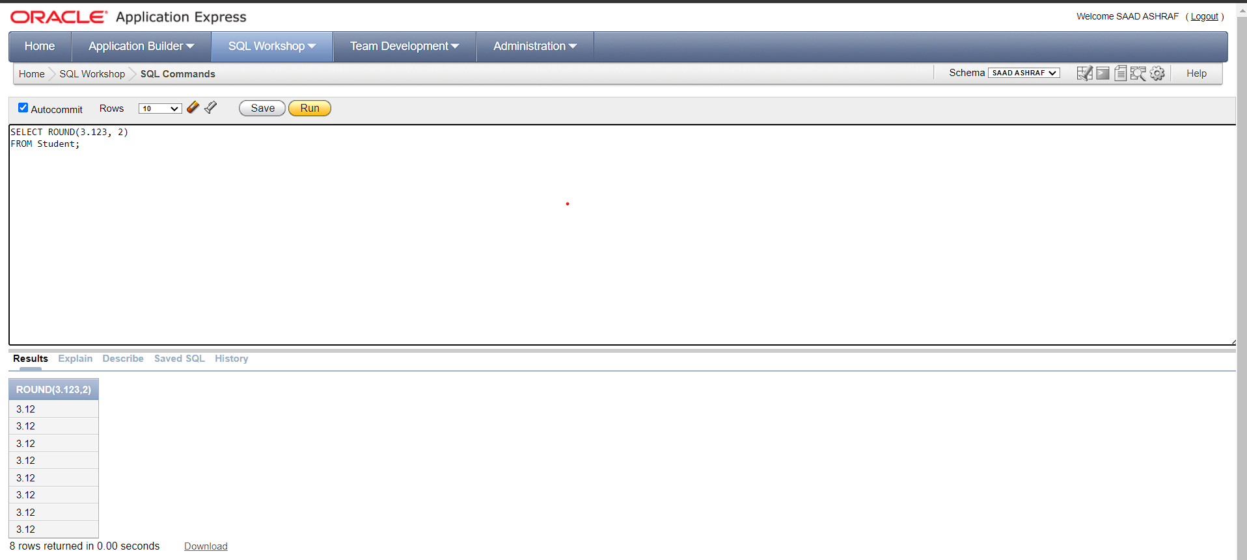

27-

SELECT LOCALTIMESTAMP FROM dual;

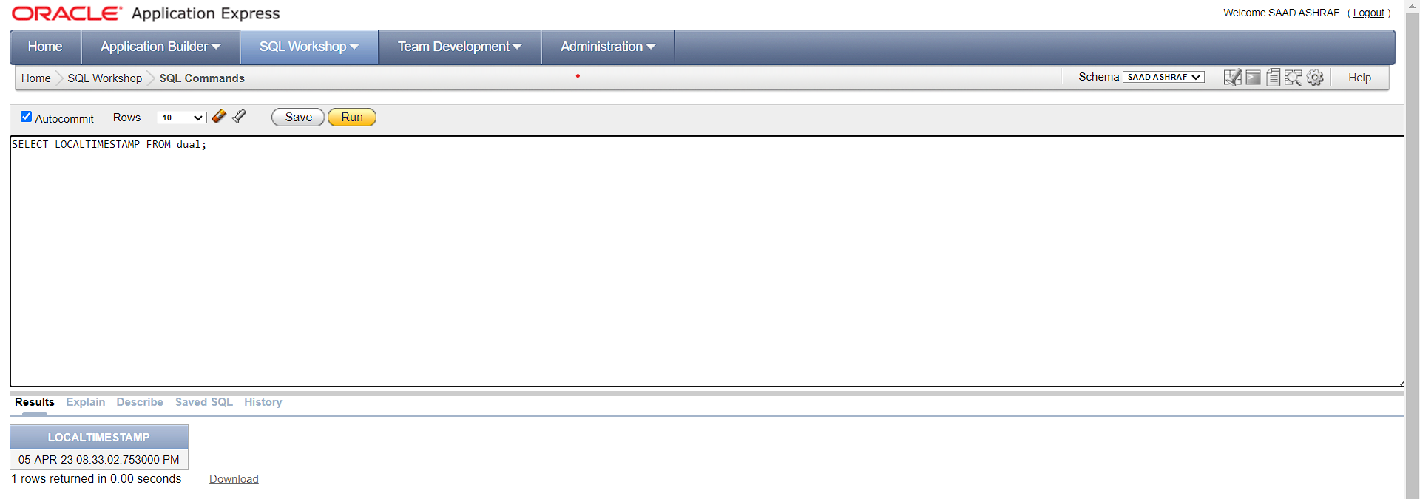

28-

SELECT CURRENT_DATE FROM dual;

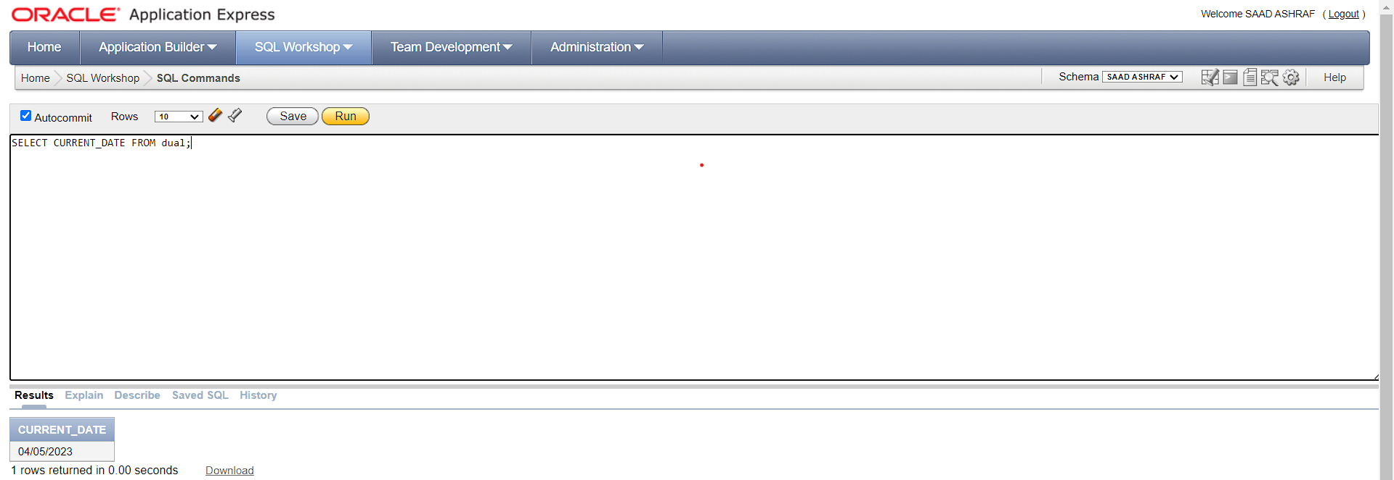

29-

SELECT SQRT(20)

FROM Student;

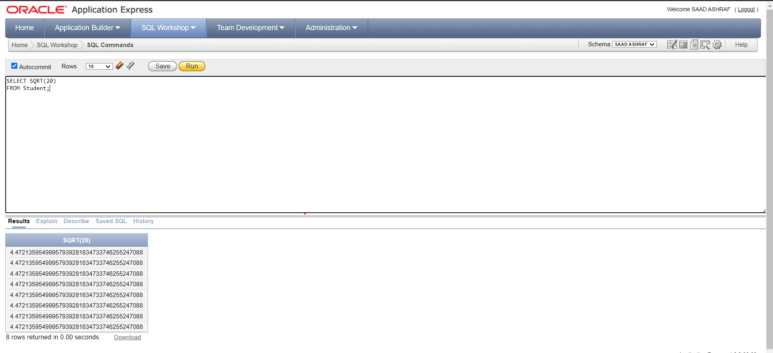

30-

SELECT SIGN(35)

FROM Student;

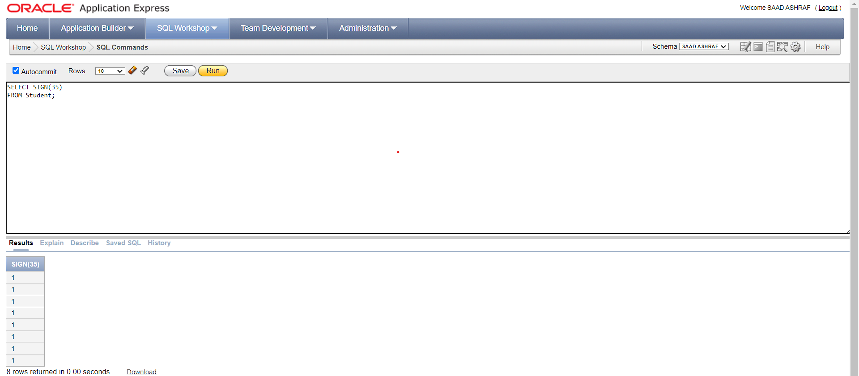

31-

SELECT EXP(10)

FROM Student;

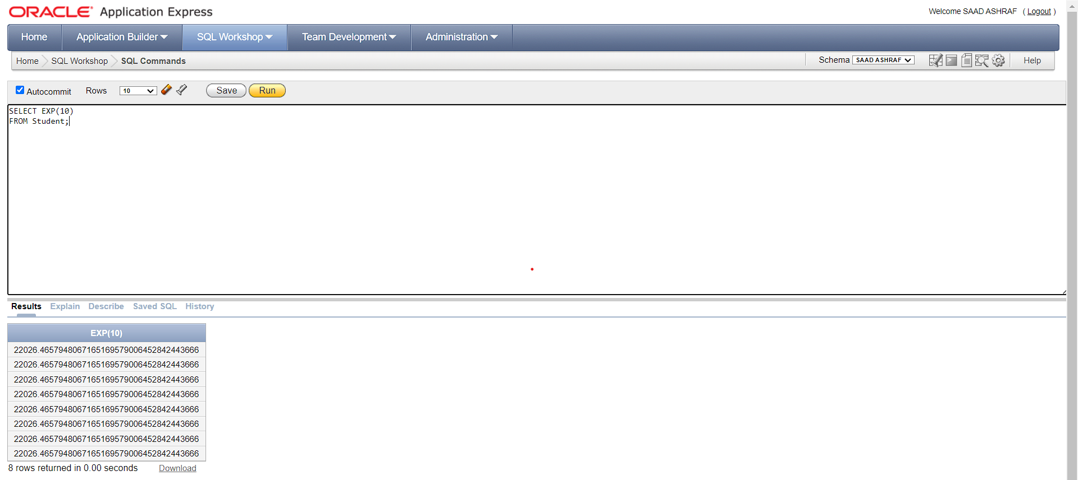

32-

SELECT LN(1.11238)

FROM Student;

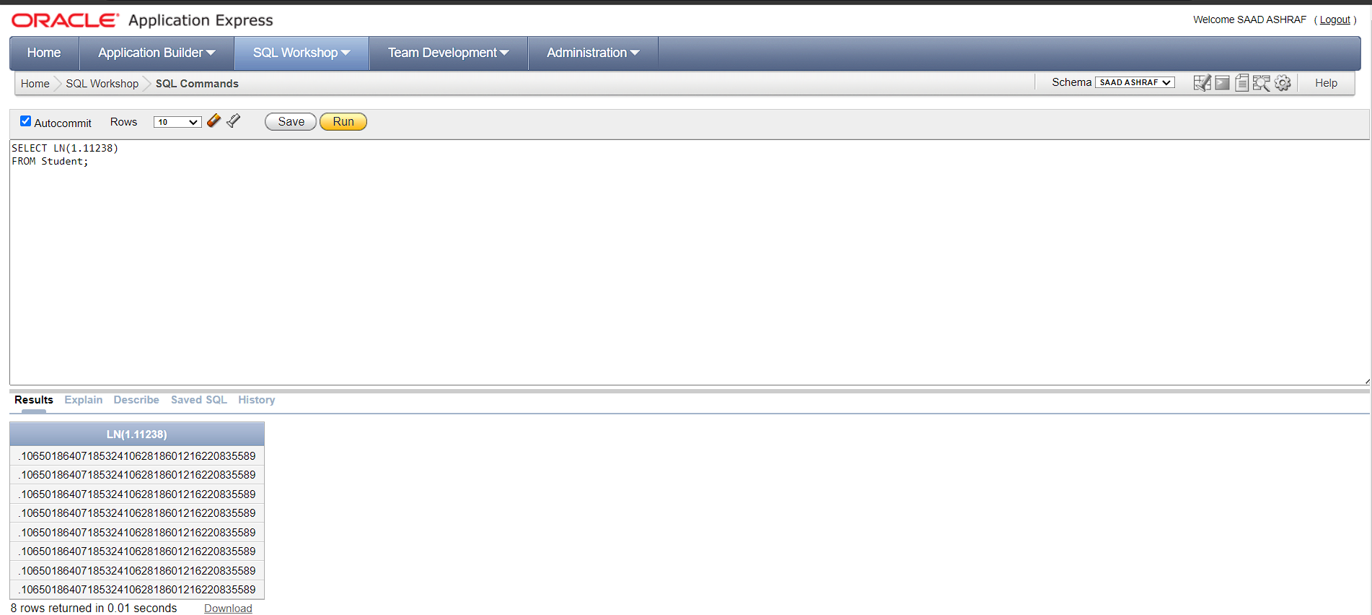

33-

SELECT TRUNC(2.2363, 3)

FROM Student;

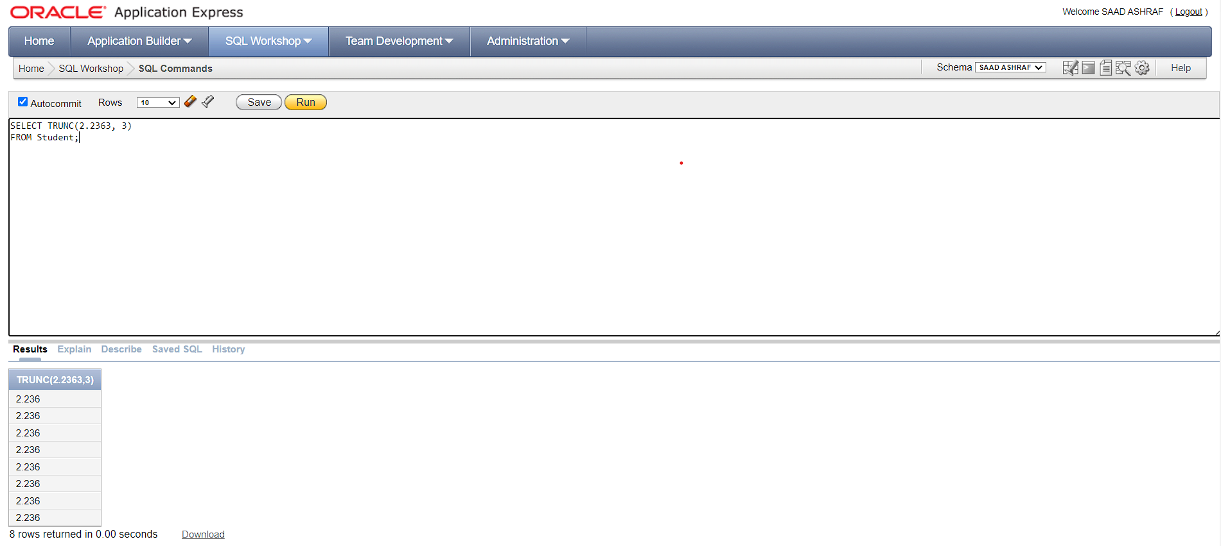

34-

SELECT SIN(90)

FROM Student;

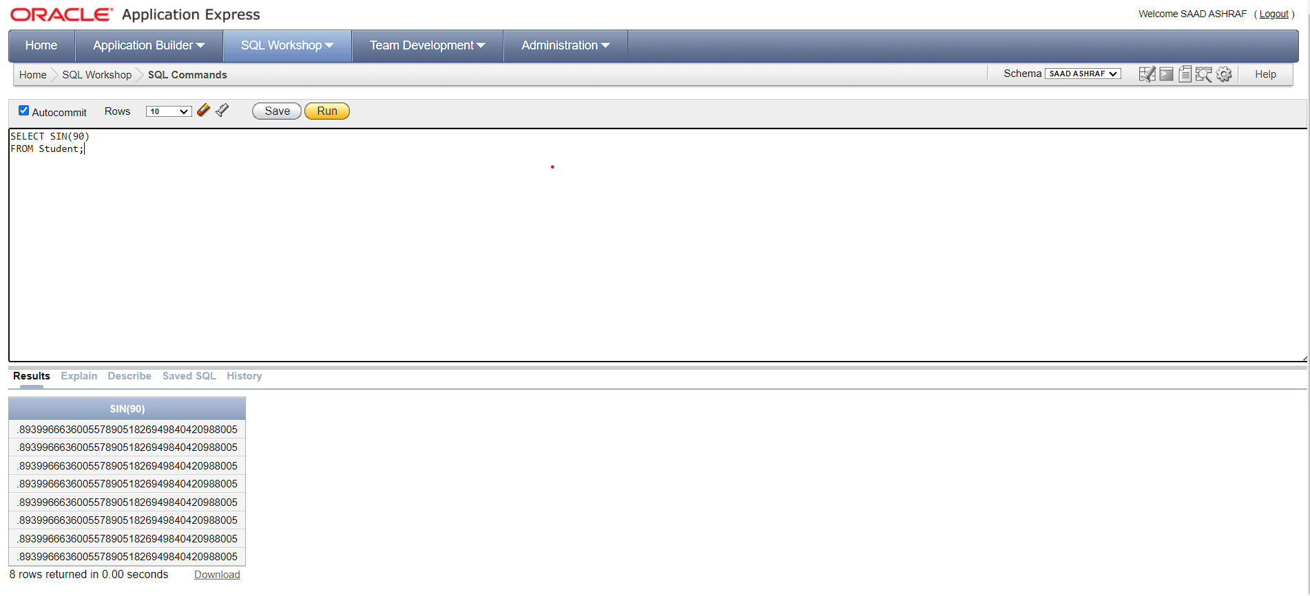

35-

SELECT COS(90)

FROM Student;

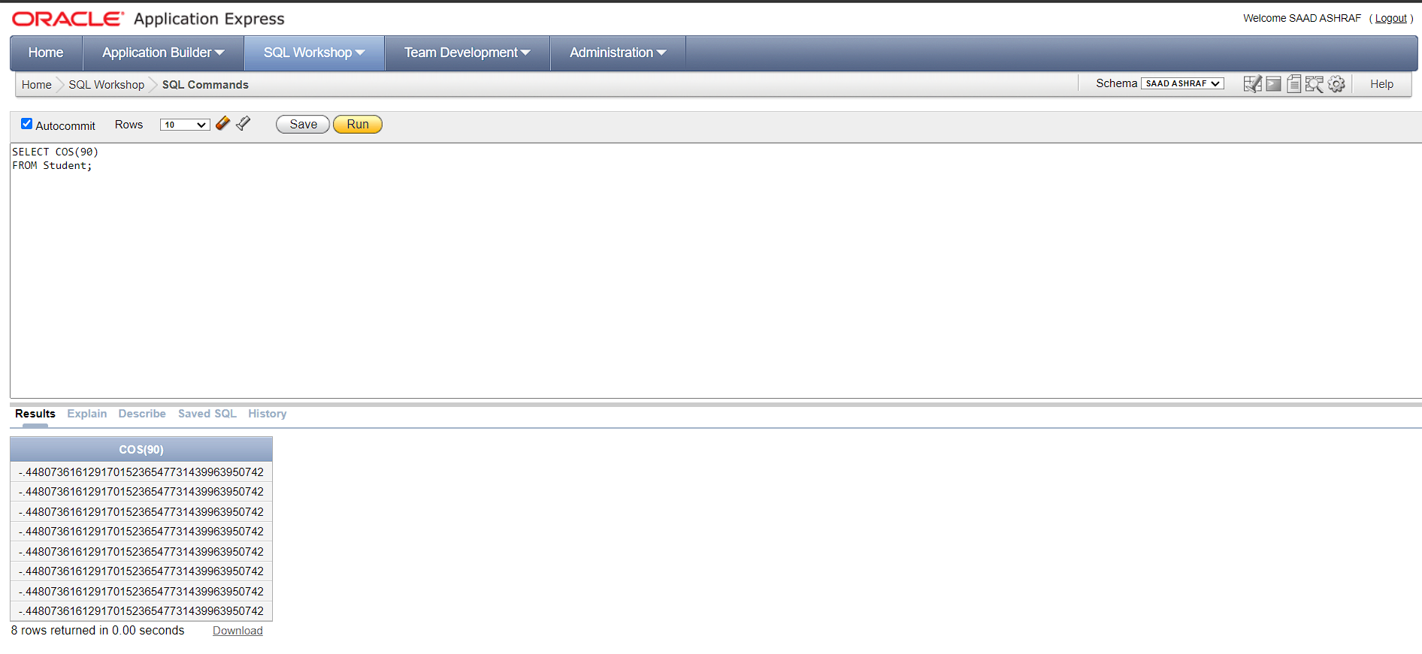

36-

SELECT TAN(90)

FROM Student;

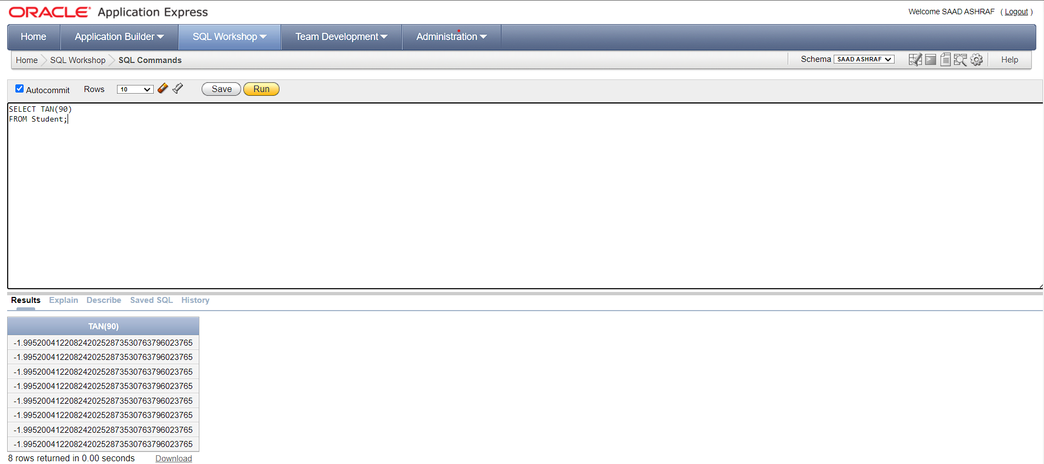

37-

SELECT SYSDATE

FROM Student;

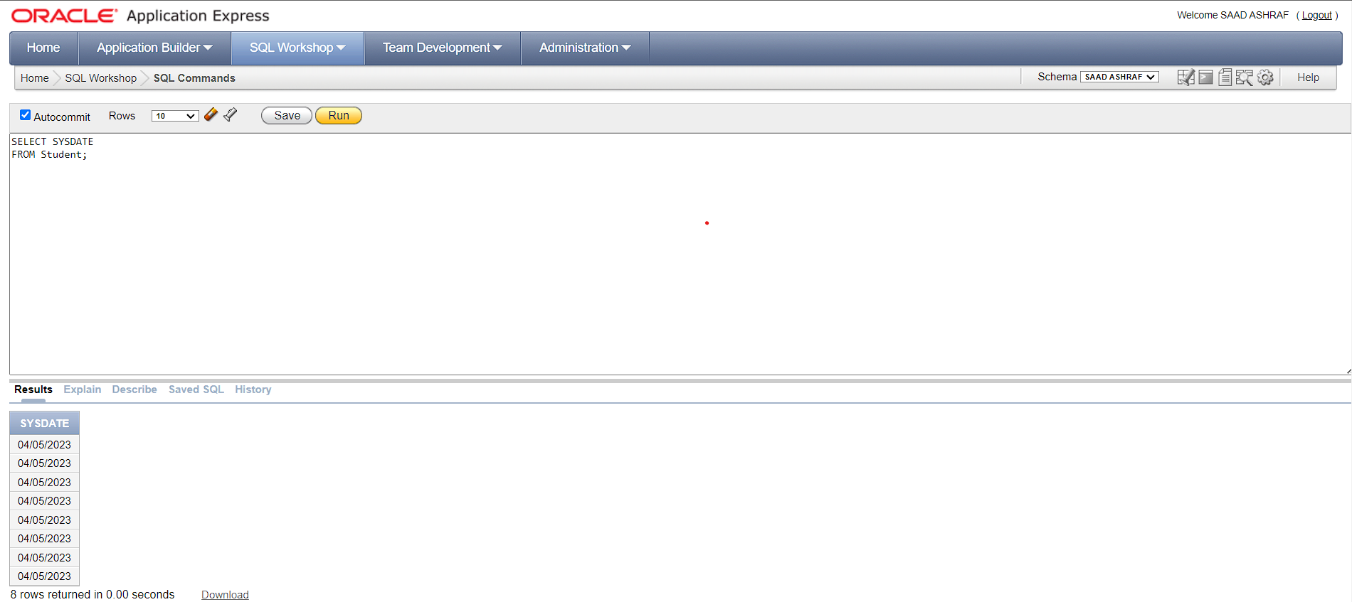

38-

SELECT SUBSTR(STDNAME, 1, 4) AS First_four_Chars

FROM Student;

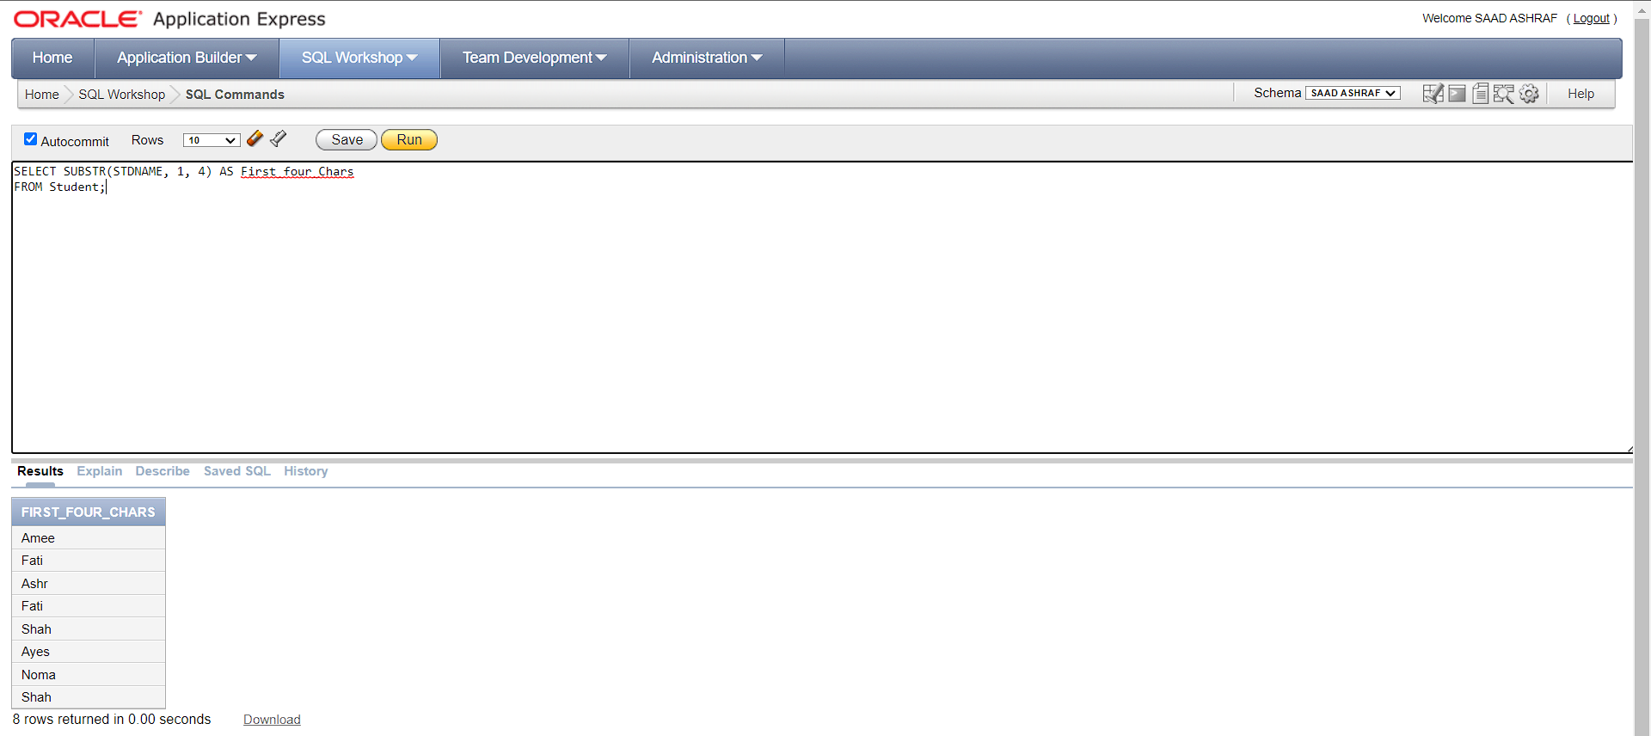

39-

SELECT EXTRACT(YEAR FROM JOIN_DATE) AS JOIN_DATE

FROM GYM;

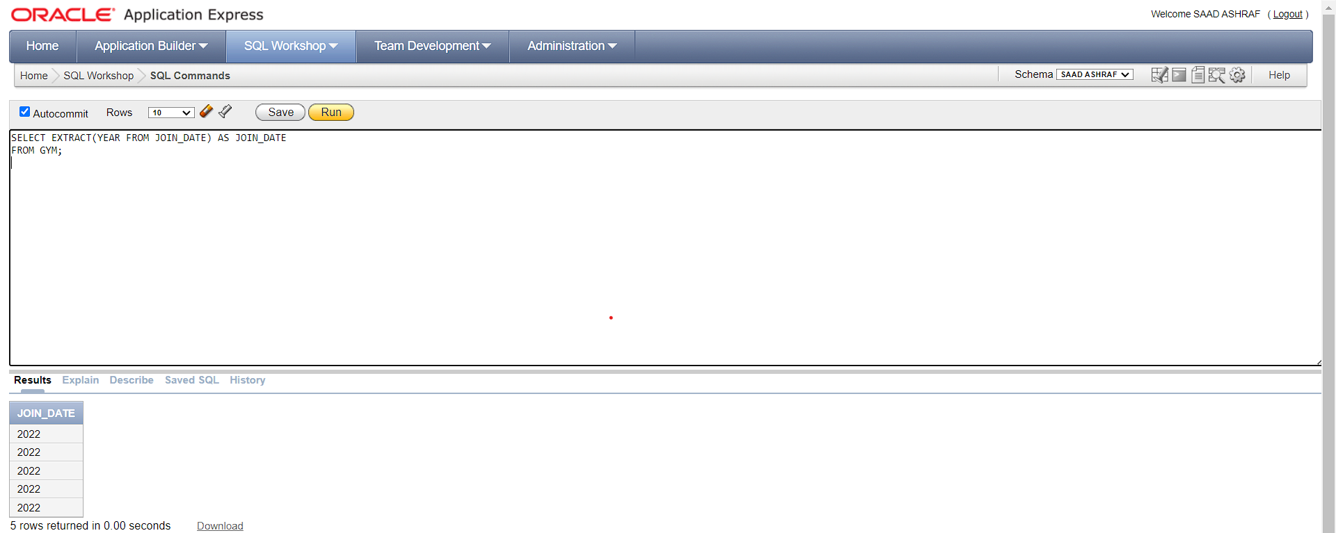

40-

SELECT TO_CHAR(JOIN_DATE, 'MM/DD/YYYY') AS JOIN_DATE_formatted

FROM GYM;

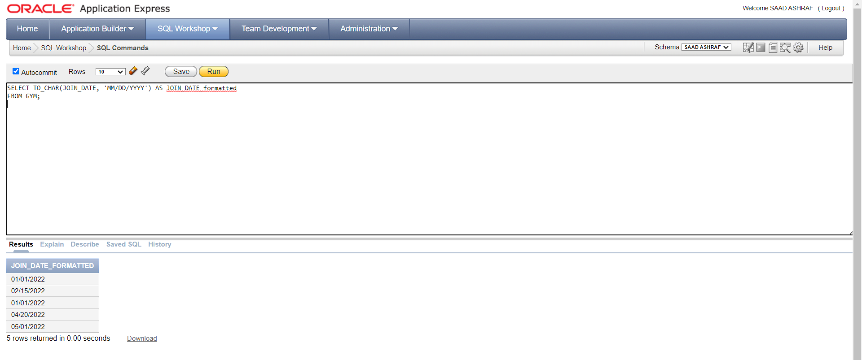

41-

SELECT JOIN_DATE + (6/24) AS six_hours_later

FROM GYM;

